LLM-Based Intelligent Personal Finance Advisor with Personalized Savings Prediction and Investment Recommendation
A Mini Project Report Submitted in partial fulfillment of the requirements for the award of the degree of

BACHELOR OF TECHNOLOGY
In

DEPARTMENT OF COMPUTER SCIENCE AND ENGINEERING
By
D. Hari Haran – 2420080075
P. Jyothik Kshitij – 2420080039
K. Narasimha Sai – 2420030406

Ch. Srikar – 2420030610

Under the Esteemed Guidance of

Dr. K. Swanthana





K L (Deemed to be) University

DEPARTMENT OF COMPUTER SCIENCE AND ENGINEERING

DECLARATION

The mini-project report entitled LLM-Based Intelligent Personal Finance Advisor with Personalized Savings Prediction and Investment Recommendation
This mini-project report entitled “LLM-Based Intelligent Personal Finance Advisor with Personalized Savings Prediction and Investment Recommendation” is a record of bona fide work carried out by D. Hari Haran (2420080075), P. Jyothik Kshitij (2420080039), K. Narasimha Sai (2420030406), and Ch. Srikar (2420030610), in partial fulfillment of the requirements for the award of the B.Tech degree at K L (Deemed to be) University. The work is original to the best of our knowledge. External datasets, libraries, APIs, and research sources will be acknowledged appropriately.
D. Hari Haran – 2420080075
P. Jyothik– 2420080039
K. Narasimha-2420030406
Ch. Srikar-2420030610

K L (Deemed to be) University

DEPARTMENT OF COMPUTER SCIENCE AND ENGINEERING

CERTIFICATE

This is to certify that the mini-project report entitled LLM-Based Intelligent Personal Finance Advisor with Personalized Savings Prediction and Investment Recommendation
This is to certify that the mini-project report entitled “LLM-Based Intelligent Personal Finance Advisor with Personalized Savings Prediction and Investment Recommendation” is a bona fide work carried out by D. Hari Haran (2420080075), P. Jyothik Kshitij (2420080039), K. Narasimha Sai (2420030406), and Ch. Srikar (2420030610), under the supervision of Dr. K. Swanthana during the academic year 2026–2027, in partial fulfillment of the requirements for the award of the Bachelor of Technology degree at K L (Deemed to be) University.

Signature of the Project Supervisor

Signature of the HOD Signature of the External Examiner

ACKNOWLEDGEMENT
The success in this project would not have been possible but for the timely help and guidance rendered by many people. Our wish to express my sincere thanks to all those who has assisted us in one way or the other for the completion of my project.

We express our sincere gratitude to our project guide, Dr. K. Swanthana, for her valuable guidance, encouragement, and constructive feedback throughout the development of this project. Her support helped us refine the problem definition, plan the system architecture, and approach implementation systematically.

We are thankful to the Head of the Department and the faculty and technical staff of the Department of Computer Science and Engineering, K L (Deemed to be) University, for providing the academic environment and facilities required to undertake this project. We also thank our classmates and families for their encouragement and cooperation.

We thank all the members of teaching and non-teaching staff members, and also who have assisted me directly or indirectly for successful completion of this project. Finally, I sincerely thank my parents, friends and classmates for their kind help and cooperation during my work.
D. Hari Haran – 2420080075
P. Jyothik– 2420080039
K. Narasimha-2420030406

Ch.Srikar-2420030610

TABLE OF CONTENTS

S.No. | Contents | Page no.
1. | Abstract
2. | Introduction
3. | Literature survey
4. | Problem Statement and Objectives
5. | Hardware and Software requirements
6. | Implementation
7. | Results & Discussion
8. | Conclusion & Future Scope
9. | References

ABSTRACT

This project proposes an LLM-Based Intelligent Personal Finance Advisor that combines machine-learning-based savings prediction with personalized budgeting guidance. Users can enter their income, expense amounts, expense categories, and financial goals. The application organizes these records, calculates basic financial indicators, and uses an XGBoost regression model to estimate potential monthly savings from historical or prepared tabular financial data. A financial-health module summarizes income–expense balance and highlights areas where spending may be reduced. An LLM-based advisor converts the numerical summaries and user-stated goals into clear, personalized explanations and budgeting suggestions. The planned application uses a React frontend, a FastAPI backend, SQLite for structured storage, Python data-science libraries, and visualization components for charts. Model performance is assessed using regression metrics such as Mean Absolute Error (MAE) and the coefficient of determination (R²); the API and database are checked through functional tests. In an initial training run previously recorded for the project dataset, the model achieved MAE of ₹2,068.48 and R² of 0.97. These figures are preliminary and depend on the dataset and split; they should be revalidated on held-out data before being presented as final results. The system is intended for educational decision support, not as a substitute for a qualified financial adviser.
Team Name:

Dharmayodha

Team Members and Responsibilities:

- 1. D. Hari Haran – 2420080075: Data preparation, exploratory analysis, and documentation.
- 2. P. Jyothik Kshitij – 2420080039: Backend/API development and database integration.
- 3. K. Narasimha Sai – 2420030406: Machine-learning pipeline, savings prediction, and model evaluation.
- 4. Ch. Srikar – 2420030610: Frontend integration, visualization, testing, and report coordination.

- Dataset/source and project repository (if applicable):
- Dataset: project financial-data CSV (locally prepared/curated for development; document the exact final source, record count, licence, and train/test split before submission). Repository: to be added after the team creates and publishes its project repository.

INTRODUCTION

Personal financial planning requires users to understand how income, spending habits, and savings goals interact. Manually reviewing transaction records can be time-consuming, and users may find it difficult to estimate future savings or convert numerical summaries into practical actions. This project applies data analysis and machine learning to organize financial information and predict monthly savings, while a large language model (LLM) explains the results in accessible language. The LLM component is used for natural-language guidance rather than as the primary numerical prediction model.
The intended users are students, early-career professionals, and individuals who want a simple overview of their personal finances. Inputs include income amount and source, expense amount and category, optional descriptions, savings goals, and a self-selected risk preference for educational investment information. Outputs include predicted savings, income-versus-expense summaries, a financial-health indicator, spending observations, charts, and LLM-generated guidance. The pipeline is: validate and store data; clean and aggregate financial records; create numerical features; train and evaluate a regression model; expose predictions through FastAPI; and display results in a React interface. The report covers related work, objectives, requirements, implementation, evaluation, and future improvements.

The LLM-Based Intelligent Personal Finance Advisor with Personalized Savings Prediction and Investment Recommendation is designed to help users understand and improve their financial habits through an intelligent, user-friendly web application. The system combines machine learning techniques with large language models to provide financial insights based on user-provided income, expenditure, savings goals, and risk preferences.
The proposed system uses historical financial data to analyze monthly income and expenditure patterns. A machine learning model, such as XGBoost, is intended to predict monthly savings based on relevant financial features. By comparing income with expenditure, the system can help users identify spending categories that may require attention and suggest practical budgeting improvements.

In addition, the application incorporates an LLM-based financial guidance module that converts financial information into understandable explanations and personalized suggestions. The investment recommendation module can use the user's available savings, financial goals, and stated risk profile to present general investment options for further consideration. Where implemented, market information obtained through a financial data source can provide additional context for these recommendations.

The proposed personal finance advisor follows a modular architecture in which the frontend, backend, database, machine learning model, and language model work together to provide financial insights. Each component performs a specific function, making the application easier to develop, maintain, and extend.
The frontend is developed using React, which provides an interactive interface for users to enter financial information, view expenditure summaries, and access personalized recommendations. The backend is developed using Python and FastAPI, which manages application requests, performs input validation, communicates with the database, and connects the frontend with the machine learning and AI modules.

SQLite is used as the database during development to store user information, income records, and expense details. Python libraries such as Pandas and NumPy are used for financial data processing and numerical operations. Scikit-learn supports model evaluation and data preparation, while XGBoost is used for developing the monthly savings prediction model.
The LLM integration provides a natural-language interface for explaining financial summaries and generating contextual suggestions. By separating numerical prediction from language generation, the system maintains a clear distinction between calculated financial values and AI-generated explanations.

Savings prediction is one of the important features of the proposed system. Many individuals calculate their remaining money only after spending, without understanding how their financial habits may affect future savings. The proposed application aims to address this issue by using historical financial information to estimate monthly savings.
The prediction model considers relevant features such as monthly income, rent, food expenses, transportation, shopping, entertainment, and other expenditure categories, depending on the available dataset. These features are provided to the trained XGBoost regression model, which estimates the expected savings amount.
The predicted value can be compared with the user's current financial position to help identify possible improvements. For example, if expenditure is consistently high compared with income, the application can highlight the categories that contribute significantly to spending. This information can help users establish realistic savings targets and monitor their financial progress.

The financial health assessment feature is designed to provide users with a simplified understanding of their financial condition. It considers important indicators such as income, expenditure, savings ratio, and spending distribution. These indicators can be combined using a defined scoring method to generate a financial health score.
Expense monitoring provides additional information by organizing transactions into categories. Users can understand how much money is spent on essential and discretionary activities and identify areas where budgeting improvements may be possible.
The dashboard can display these results through graphical representations such as pie charts, bar charts, and income-versus-expense comparisons. These visualizations make financial information easier to interpret and allow users to identify spending patterns without manually examining every transaction.

An important feature of the proposed application is its ability to explain financial information using an LLM. Traditional expense management applications generally focus on recording transactions and displaying numerical summaries. In contrast, this project aims to convert financial observations into understandable explanations and practical suggestions.
For example, when a user enters monthly income and expenditure details, the system can provide an explanation of the spending pattern, identify categories that may require attention, and suggest ways to improve savings habits. The LLM can also explain general financial concepts such as emergency funds, budgeting methods, investment diversification, and risk management.
The investment recommendation component is designed to provide general educational information based on the user's available savings, financial objectives, and selected risk preference. It aims to help users understand different investment categories and their associated risks. The recommendations are informational and should not be considered guaranteed investment returns or professional financial advice.

The major significance of this project is the integration of machine learning-based financial prediction and LLM-powered explanations into a single application. Instead of providing only transaction records or basic calculations, the proposed system aims to deliver a more informative financial management experience.
The application can help users improve their awareness of spending habits, understand their savings potential, and make more structured financial plans. Its modular design also provides opportunities for future improvements, including additional prediction features, real-time financial data integration, enhanced visualization, and more advanced conversational capabilities.
Overall, the project demonstrates how artificial intelligence, machine learning, and web technologies can be combined to develop an accessible personal finance decision-support system. It aims to make financial analysis easier to understand and encourage users to develop better financial planning habits.

LITERATURE SURVEY
1. Chen and Guestrin (2016), “XGBoost: A Scalable Tree Boosting System.” The paper presents gradient-boosted decision trees designed for efficiency and predictive performance on structured datasets. It motivates the use of XGBoost for tabular financial features. Its results are not specific to personal budgeting, so this project must evaluate performance on its own data. https://doi.org/10.1145/2939672.2939785
2. Breiman (2001), “Random Forests.” This work describes an ensemble of decision trees for classification and regression. Random Forest can serve as a comparison model for savings prediction because it captures nonlinear relationships in tabular data. Model choice should be based on held-out evaluation rather than assumed superiority. https://doi.org/10.1023/A:1010933404324
3. Pedregosa et al. (2011), “Scikit-learn: Machine Learning in Python.” This paper documents a widely used Python toolkit for preprocessing, model training, and evaluation. The project can use its train/test splitting and regression metrics to make experiments reproducible. The library itself does not guarantee that a model generalizes to unseen users. https://doi.org/10.5555/1953048.2078195
4. Brown et al. (2020), “Language Models are Few-Shot Learners.” This work demonstrates the ability of large language models to perform a range of language tasks from prompts and examples. It supports exploring LLMs for natural-language explanations and interactive guidance. General language capability does not ensure financial accuracy, so generated advice must be constrained, checked, and clearly labelled as educational. https://doi.org/10.48550/arXiv.2005.14165
5. López-Lira and Tang (2023), “Can ChatGPT Forecast Stock Price Movements? Return Predictability and Large Language Models.” The study explores LLM sentiment analysis of news headlines in relation to stock returns. It shows a possible role for language models in financial text interpretation, but its task differs from personal savings prediction and does not establish reliable personalized investment advice. https://doi.org/10.2139/ssrn.4412788
Research gap: many tools provide expense tracking or general financial content, while this project aims to combine a transparent numerical savings estimate, spending summaries, and natural-language explanations in one student-scale prototype. Its usefulness must be judged through model evaluation, functional testing, and careful review of generated guidance.

Large Language Models for Financial Applications
Nie et al. (2024) reviewed the applications of large language models in finance, including financial reasoning, forecasting, question answering, sentiment analysis, and decision support. Their survey highlights the potential of LLMs to interpret contextual information and generate natural-language responses for complex financial tasks. It also identifies challenges involving reliability, explainability, and the responsible use of AI in financial settings. This research supports the use of an LLM in the proposed system to explain financial summaries and generate understandable budgeting guidance.
arXiv
Natural Language Processing in Finance
Du et al. (2025) presented a survey of natural language processing techniques in financial applications. The study discusses areas such as financial forecasting, portfolio management, financial question-answering systems, virtual assistants, risk management, and explainable AI. It illustrates how language technologies can help users interpret financial information and interact with intelligent systems. For the proposed project, these findings provide a foundation for developing a conversational financial assistant that explains spending patterns and communicates predictions in accessible language. However, a general-purpose language model should not be treated as a guaranteed source of financially correct advice.
ScienceDirect
Financial Advice Using ChatGPT and Robo-Advisors
The study Does ChatGPT Provide Better Advice Than Robo-Advisors? published in Finance Research Letters in 2024 compares ChatGPT with 17 robo-advisors using three investor profiles. The authors examine how the recommendations align with different risk attitudes and a benchmark derived from academic literature. The study suggests that LLMs may be useful in generating investment recommendations, while also showing why recommendations should be evaluated against appropriate criteria. This is relevant to the proposed system's investment module, which aims to consider a user's financial situation and risk profile rather than provide identical suggestions to everyone

PROBLEM STATEMENT AND OBJECTIVES

Problem Statement:
To develop and evaluate a personal-finance decision-support prototype that predicts monthly savings from structured income and expense data and uses an LLM to explain financial summaries and generate goal-aware budgeting suggestions.

Problem Description:
Individuals often record expenses without obtaining a clear estimate of future savings or actionable feedback about spending patterns. Manual calculations are repetitive, while generic advice may not reflect a user's income, expense categories, or stated goals. The proposed system combines structured financial analysis, regression-based savings prediction, visual summaries, and LLM-generated explanations. Predictions depend on data quality and should not be treated as guaranteed outcomes or regulated financial advice.
Objectives:
The project objectives are to:
- • Build a structured dataset from income and expense records and document its fields, origin, size, and limitations.
- • Validate inputs and handle missing, duplicate, inconsistent, or invalid financial values.
- • Engineer numerical features such as total income, category-wise expenses, total expenses, and historical savings where available.
- • Train an XGBoost regression model and compare it with a simple baseline or another suitable regression model.
- • Evaluate predictions using MAE and R², and report results from a clearly defined held-out test set.
- • Calculate financial summaries, highlight spending patterns, and discuss privacy, bias, data limitations, and the risks of inaccurate guidance.
- • Provide a React user interface backed by FastAPI and SQLite, with charts and an LLM-powered explanation endpoint.

HARDWARE AND SOFTWARE REQUIREMENTS
- A laptop or desktop computer with a modern multi-core CPU and at least 8 GB RAM is recommended.
- Internet access is needed to install packages and call the configured LLM/market-data APIs. A GPU is not required for the planned tabular regression model.
- Allow sufficient disk space for source code, the SQLite database, datasets, saved model files, and evaluation plots.
Software Requirements:
- Python 3.10 or a compatible supported version; Node.js and npm for the React/Vite frontend; Visual Studio Code for development.
- Python packages: pandas, NumPy, scikit-learn, XGBoost, SQLAlchemy, FastAPI, Uvicorn, python-dotenv, and an LLM provider SDK. Frontend: React, Vite, and a charting library such as Recharts or Plotly.
- Structured financial records stored as CSV during model development and SQLite tables for application data. The final report must state whether the dataset is synthetic, manually prepared, or drawn from an external source.
- FastAPI provides the backend API; React provides the user interface; SQLite stores records; Git is recommended for version control. yfinance may be used for public market data if implemented, but market data must not be presented as a guaranteed investment recommendation.

Database and Data Management: SQLite is used for storing user details, income records, and expense information. SQLAlchemy provides database connectivity and supports structured data operations.

Machine Learning Environment: XGBoost and Scikit-learn are required for training, evaluating, and executing the monthly savings prediction model. Joblib is used to save and load the trained model.

API Communication: HTTP-based communication is used between the React frontend and FastAPI backend. JSON is used as the data exchange format for sending financial information and receiving prediction results.

Internet and External Services: An active internet connection is required for installing dependencies, accessing external LLM APIs, and retrieving market information through services such as Yahoo Finance, if implemented. API keys should be stored securely using environment variables.

Project Implementation :

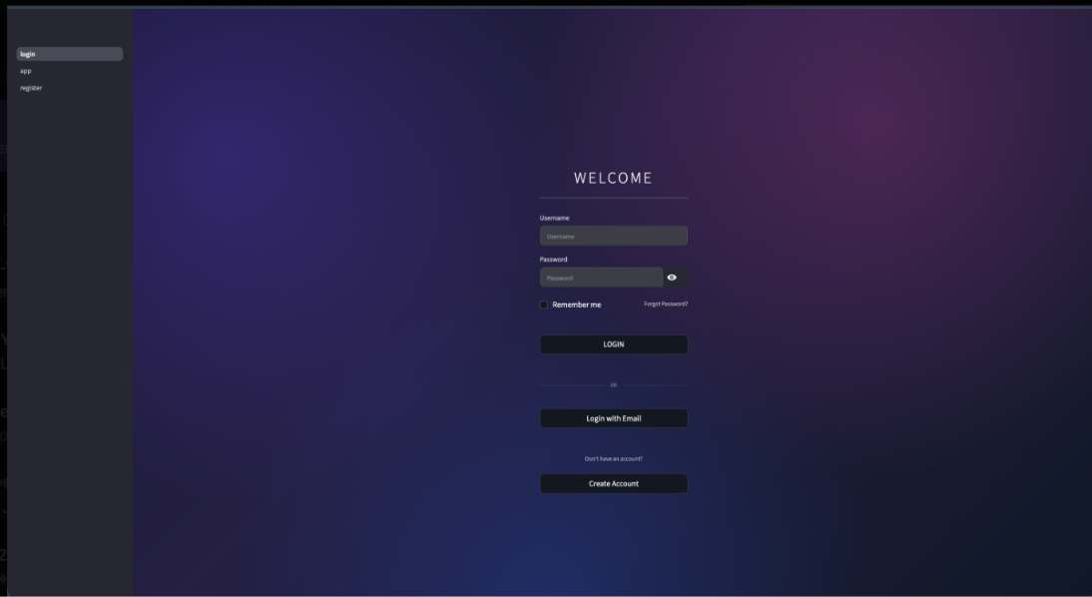

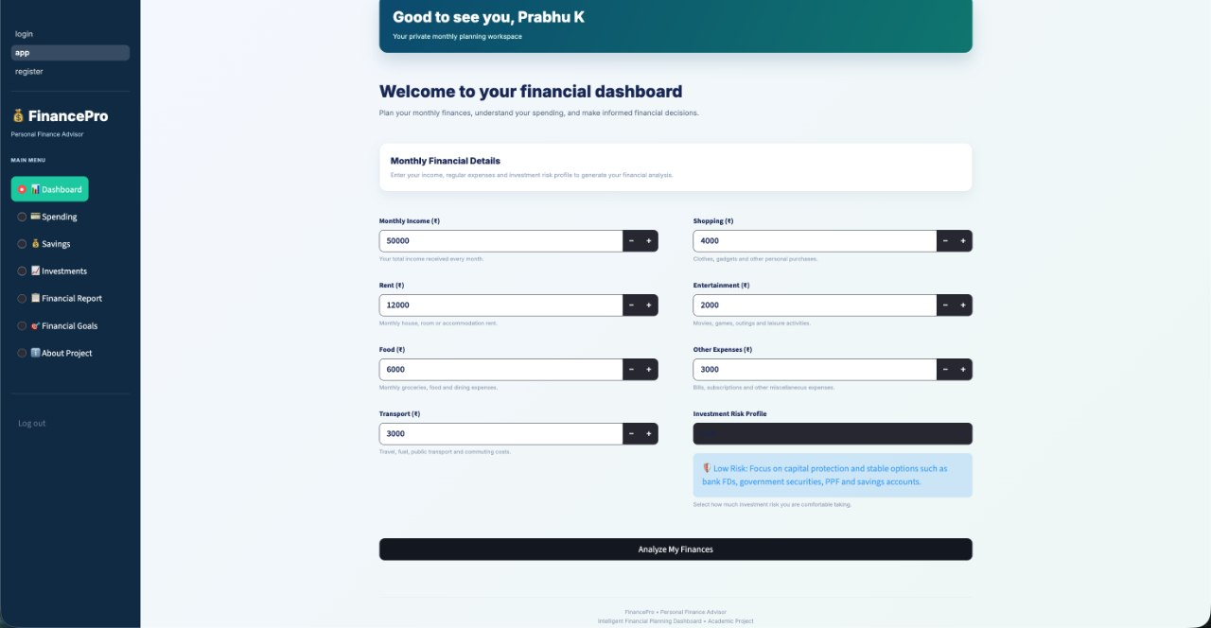

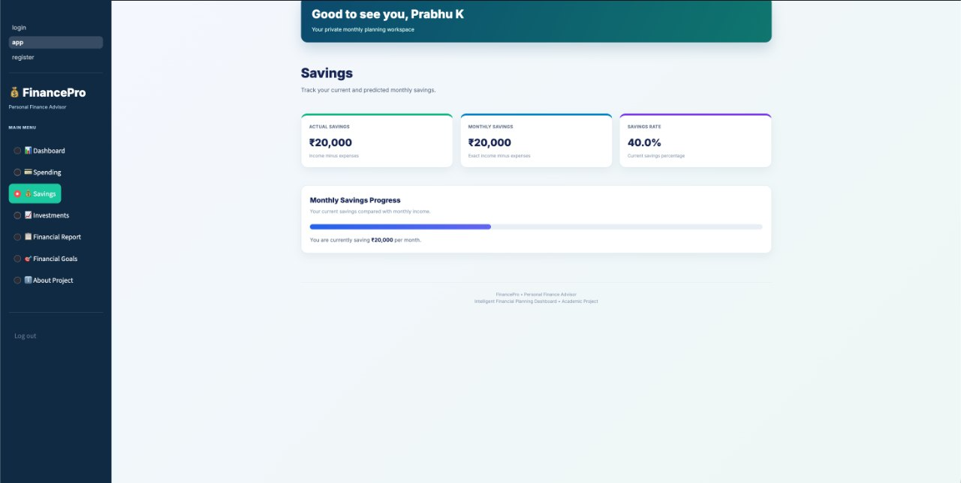

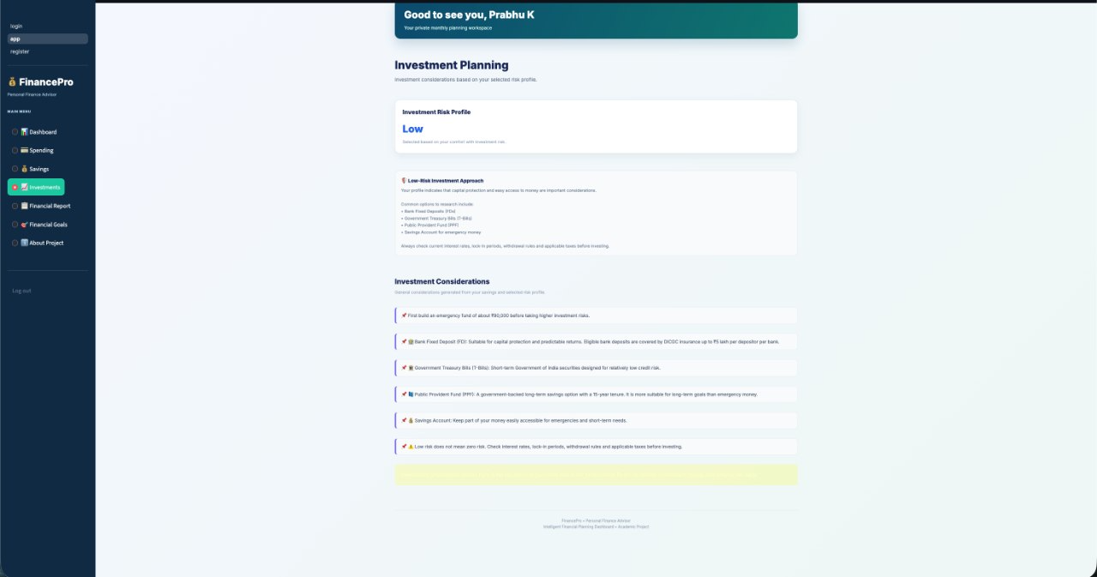

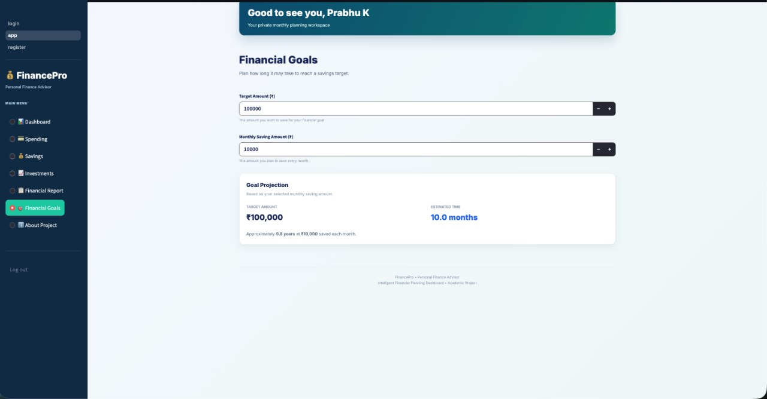

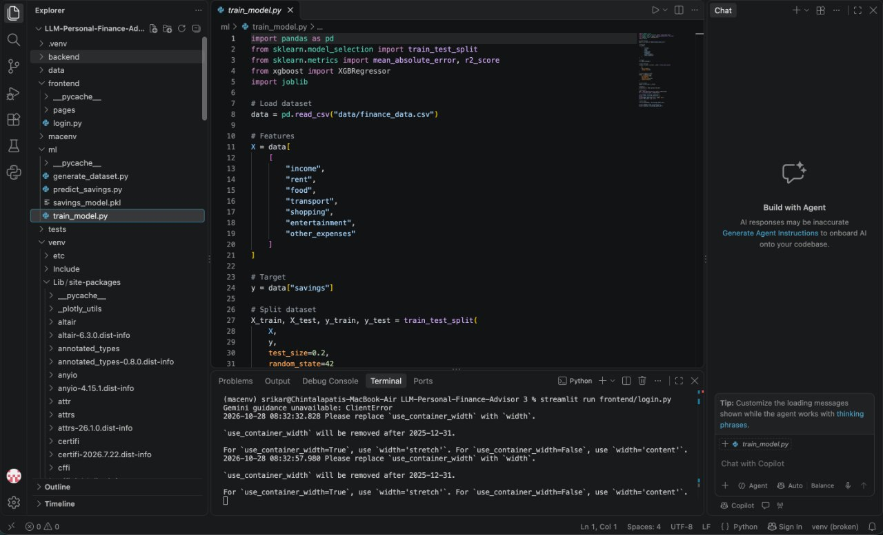

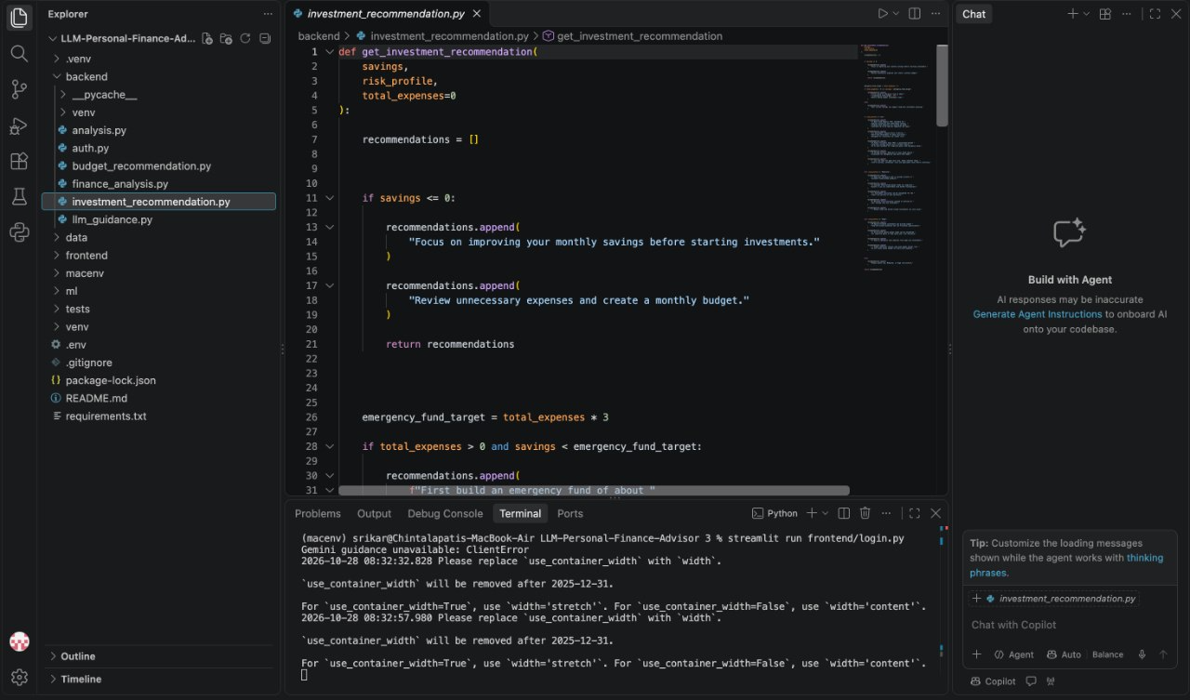

IMPLEMENTATION
The implementation of the LLM-Based Intelligent Personal Finance Advisor with Personalized Savings Prediction and Investment Recommendation involves integrating data processing, machine learning, database management, backend development, frontend development, and large language model capabilities into a unified web application. The system is designed to analyze personal financial information, predict monthly savings, evaluate financial health, and provide understandable financial guidance.
The implementation is divided into different modules to ensure that each component performs a specific responsibility. Python is used for financial data processing and machine learning, XGBoost is used for savings prediction, FastAPI manages backend services, SQLite stores application information, and React provides an interactive user interface.
The primary machine learning task in this project is a regression problem. The objective is to predict the estimated monthly savings of an individual based on financial information such as income and expenditure. Unlike classification problems, which predict categories or labels, regression predicts a continuous numerical value representing the expected savings amount in Indian Rupees (INR).

The dataset used for model development is maintained in CSV format with the filename finance_data.csv. It contains financial attributes representing income and different expenditure categories. The features include monthly income, rent, food expenses, transportation expenses, shopping expenses, entertainment expenses, and other expenses. These attributes help the model identify relationships between a person's income, spending behaviour, and savings.

The target variable is monthly savings. It represents the amount of money remaining after accounting for the relevant expenditure values. The dataset is loaded into Python using the Pandas library, which provides functions for reading, examining, filtering, and manipulating structured data.

The following steps are performed during data collection and inspection:
- Load the financial dataset using the Pandas library.
- Examine the dataset structure, column names, and data types.
- Identify the input features and target variable.
- Check the number of records and identify missing or duplicate entries.
- Verify that financial amounts contain valid numerical values.
- Inspect the distribution of income, expenses, and savings.
- Prepare the dataset for training and testing.

The dataset should be documented with its actual source, number of rows, number of columns, and data-generation method. If the records are synthetically generated for academic development, they must be identified as synthetic data rather than real banking transactions.

Data preprocessing is an important stage because the quality of the input data directly influences the reliability of machine learning predictions. Financial datasets may contain missing values, duplicate records, inconsistent formats, or invalid numerical entries. These issues must be handled before training the prediction model.

Initially, the dataset is checked for missing values and duplicate records. Missing numerical values are handled using an appropriate strategy, while duplicate records are examined to avoid unnecessary repetition. Financial attributes such as income and expenditure are converted into suitable numerical formats. Negative values and unrealistic amounts are checked according to the meaning of each feature.

The expenditure categories are maintained in a consistent format so that similar expenses are represented uniformly. For example, transportation expenses should not be stored under different names such as transport, travel, and transportation without a defined mapping.

Feature engineering is performed to create meaningful numerical attributes from the available financial records. These may include:
- Total Income: The combined monthly income from the available income sources.
- Total Expenses: The sum of all recorded expenditure categories.
- Monthly Savings: The difference between total income and total expenses, where the dataset defines savings this way.
- Savings Ratio: The percentage of income remaining after expenses.
- Category-wise Spending: The amount spent on individual categories such as rent, food, transport, and shopping.
- Expense-to-Income Ratio: The proportion of income used for expenditure.
The following formulas can be used to calculate financial features:
Total Expenses
Total Expenses = Rent + Food + Transport + Shopping + Entertainment + Other Expenses
Monthly Savings
Monthly Savings = Total Income − Total Expenses
Savings Ratio
Savings Ratio = (Monthly Savings / Total Income) × 100
These derived features help the model understand the relationship between income and spending behaviour. However, the target variable must not accidentally be included among the input features. Features calculated directly from the target should also be excluded when they would reveal the answer to the model, as this would cause data leakage.

Since the project focuses on numerical financial prediction, TF-IDF, tokenization, and text classification techniques are not required for the primary savings prediction model. The main input consists of structured numerical financial attributes.

After preprocessing, the dataset is divided into training and testing subsets. The training dataset is used to teach the machine learning algorithm, while the testing dataset is used to evaluate how well the trained model performs on unseen records.
The train_test_split function from Scikit-learn can be used to divide the dataset. A reproducible random seed is selected so that the same split can be obtained during repeated experiments. The selected split ratio and random seed are documented in the final implementation report.
The input variables are represented by X, while the target variable is represented by Y.
- X represents financial attributes such as income, rent, food, transport, shopping, entertainment, and other expenses.
- Y represents the monthly savings amount that the model is expected to predict.
The prepared training data is provided to the XGBoost Regressor algorithm. During training, the model learns relationships between financial attributes and the target savings value.
The training process involves the following steps:
- Import the required Python libraries.
- Load the financial dataset.
- Select the input features and target variable.
- Divide the dataset into training and testing subsets.
- Initialize the XGBoost Regressor model.
- Train the model using the training data.
- Generate predictions using the testing data.
- Calculate evaluation metrics.
- Save the trained model using Joblib for later use.
The trained model is saved as savings_model.pkl. This allows the backend application to load the model without performing the entire training process every time a user requests a prediction.

XGBoost (Extreme Gradient Boosting) is the primary machine learning algorithm selected for monthly savings prediction. It is based on gradient-boosted decision trees, where multiple decision trees are built sequentially to improve prediction performance.
Each new tree attempts to reduce the errors made by the previous trees. By combining the outputs of multiple trees, XGBoost can learn complex relationships between financial features and savings amounts.
The model is suitable for structured financial datasets because it can identify nonlinear relationships among different input variables. For example, the relationship between monthly income and savings may change depending on rent, transportation costs, and other expenditure categories.
The model is trained using the prepared financial dataset. Important parameters include the number of estimators, learning rate, maximum tree depth, and other regularization settings. These parameters can be adjusted to improve model performance and reduce overfitting.
After training, the model is evaluated using appropriate regression metrics. The Mean Absolute Error (MAE) measures the average absolute difference between actual and predicted savings. The R² score indicates how much variation in the target variable is explained by the model relative to a constant-mean baseline.
The following formulas describe the evaluation metrics:
Mean Absolute Error
MAE = (1/n) × Σ |Actual Savings − Predicted Savings|
Coefficient of Determination
R² = 1 − (Sum of Squared Prediction Errors / Total Sum of Squares)
A lower MAE indicates smaller average prediction errors, while an R² value closer to 1 generally indicates a better fit on the evaluated dataset. However, both metrics must be interpreted using the test dataset and in the context of its size and characteristics.

Model evaluation is performed to understand the reliability of the savings prediction component. The actual savings values from the test dataset are compared with the corresponding predicted values generated by the trained model.
The project previously recorded a preliminary training result of MAE = ₹2,068.48 and R² = 0.97. These values should be treated as preliminary until the exact dataset, preprocessing steps, target definition, and train/test split have been verified and the evaluation has been reproduced.
The model can also be compared with a simple baseline regressor and a Random Forest Regressor. All models should be evaluated using the same training and testing records to ensure a fair comparison. The final model should be selected based on its performance on unseen data rather than training accuracy alone.
Once the model is evaluated, the trained file is stored using Joblib. The prediction module loads the saved model and accepts financial inputs in the same feature order and format used during training. The output is a numerical estimate of the user's monthly savings.

The backend of the application is developed using Python and FastAPI. It acts as the communication layer between the React frontend, database, machine learning model, and LLM-based financial advisor.
FastAPI provides API endpoints through which the frontend can submit user details, income information, expense records, and prediction requests. It also supports request validation and automatic API documentation.
The backend is organized into separate modules to improve maintainability and code organization. The user module handles registration-related operations, while the financial modules manage income, expenses, savings predictions, and investment information.
The backend performs the following operations:
- Receives requests from the frontend.
- Validates the submitted financial information.
- Stores and retrieves records from the SQLite database.
- Processes the required financial calculations.
- Loads the trained XGBoost model for savings prediction.
- Sends relevant financial summaries to the LLM guidance module.
- Returns prediction results and financial insights to the frontend.
FastAPI also provides an interactive Swagger interface through which API endpoints can be tested during development.

SQLite is used as the database management system during project development. It provides a lightweight approach for storing application information without requiring a separate database server.
The database is designed to maintain user information, income records, and expense records. The SQLAlchemy library is used to connect the Python backend with the SQLite database and perform database operations using Python objects.
The database contains the following main entities:
User Table: Stores user-related information such as user ID, username, and email address.
Income Table: Stores income records associated with each user, including the income amount and source.
Expense Table: Stores expenditure records associated with each user, including expense amount, category, and description.
Relationships between these tables allow the application to associate financial records with the corresponding user. This structure supports the retrieval and analysis of financial information for individual users.
Database integration helps maintain organized financial records and reduces the need to enter the same information repeatedly. Appropriate validation and access controls should be implemented to protect personal financial information.

The frontend is developed using React to provide an interactive and user-friendly interface. It allows users to access the application's financial features without directly interacting with Python scripts or database operations.
The interface is designed to include registration and login pages, a financial dashboard, income and expense entry forms, savings prediction displays, and financial guidance sections.
The dashboard presents important financial indicators such as total income, total expenses, estimated savings, and financial health information. Charts and graphical representations help users understand the distribution of their expenditure and compare income with expenses.
React communicates with the FastAPI backend through HTTP requests. When a user enters financial information, the frontend sends the data to the appropriate API endpoint. The backend processes the request and returns the result, which is then displayed on the interface.
The frontend is intended to make financial analysis simple, accessible, and understandable, even for users without technical knowledge of machine learning.
The LLM module is integrated to provide natural-language explanations and personalized financial guidance. Unlike the XGBoost model, which produces numerical savings predictions, the LLM focuses on understanding financial summaries and presenting useful information in human-readable language.
The system can provide relevant context to the LLM, including income, expenditure, predicted savings, savings goals, and risk preferences. Based on this information, it can generate suggestions related to budgeting, expense management, savings habits, and general investment awareness.
For example, when a user's spending is high compared with income, the advisor can explain the spending pattern and suggest reviewing selected expense categories. It can also explain basic investment concepts based on the user's stated risk preference.
The LLM should receive validated financial summaries rather than unnecessary personal identifiers. Its responses should be treated as informational guidance and not as guaranteed financial advice. Numerical calculations and savings predictions remain the responsibility of the backend and trained machine learning model.
The complete application follows a sequential workflow in which the different modules communicate to produce the final financial insights.
First, the user provides income and expenditure information through the React interface. The frontend sends the information to the FastAPI backend, where the submitted values are validated. The backend stores the records in the SQLite database and retrieves the financial information required for analysis.
Next, the financial analysis module calculates total income, total expenses, remaining savings, and category-wise expenditure. The prepared numerical features are passed to the trained XGBoost model, which generates the estimated monthly savings.
The backend then prepares a financial summary for the LLM module. The LLM generates explanations and suggestions based on the supplied context. Finally, the prediction, financial summary, charts, and guidance are returned to the React interface for display.
This modular integration ensures that financial calculations, machine learning predictions, and language generation are handled by their respective components.
Testing is performed to verify that the individual modules and the complete application function correctly. Each component is tested independently before evaluating the integrated system.
The dataset loading and preprocessing modules are checked to ensure that financial values are handled correctly. The prediction module is tested using valid input records and evaluated using regression metrics. Backend endpoints are tested through the FastAPI Swagger interface, while database operations are checked to ensure that records are stored and retrieved correctly.
The frontend is tested to verify that forms accept valid information, API requests are processed correctly, and results are displayed in the appropriate sections. The LLM module is tested using different financial summaries to examine whether its responses are relevant and understandable.
Input validation is also important. The system should handle missing values, invalid amounts, and incomplete requests appropriately instead of producing misleading results.

The implementation combines data processing, machine learning, database management, backend services, frontend development, and LLM-based guidance into one personal finance application. The XGBoost model performs monthly savings prediction, while FastAPI manages application requests and SQLite stores financial information. React provides the user interface, and the LLM component generates natural-language explanations and financial suggestions.
The modular architecture makes the application easier to maintain and provides opportunities for future enhancements. The overall implementation aims to demonstrate how machine learning and large language models can work together to support personal financial planning and improve users' understanding of their financial behaviour.

- Project workflow and modules

A. PROJECT WORKFLOW AND MODULES
The proposed LLM-Based Intelligent Personal Finance Advisor follows a systematic and modular development approach to simplify personal financial management. The complete workflow is divided into multiple stages, starting from financial data collection and preprocessing to machine learning model development, evaluation, and application integration. Each module is designed to perform a specific function while maintaining proper communication with the other components of the system.
The project workflow begins with collecting and loading financial records containing income details, expenditure categories, and savings information. The collected data is processed using Python libraries such as Pandas and NumPy to identify missing values, remove inconsistencies, and prepare meaningful financial features. After preprocessing, the XGBoost regression model is trained using the prepared dataset to predict monthly savings. The model's performance is evaluated using appropriate metrics such as Mean Absolute Error (MAE) and R² score to understand the accuracy of its predictions.
Finally, the trained machine learning model is integrated with the FastAPI backend, SQLite database, and React frontend to develop a complete web-based application. The LLM-based advisor is incorporated to explain financial results, provide budgeting suggestions, and offer general investment guidance based on user preferences. The application presents financial summaries, savings predictions, and graphical visualizations through an interactive dashboard. This modular workflow makes the system easier to develop, test, maintain, and improve in future versions.

1. Data Loading and Exploratory Data Analysis
The first module focuses on loading and understanding the financial dataset. The project uses a CSV file named finance_data.csv, which contains financial attributes such as monthly income, rent, food, transportation, shopping, entertainment, and other expenses. Python's Pandas library is used to load the dataset and examine its structure. Exploratory Data Analysis (EDA) is performed to understand the number of records, column names, data types, missing values, duplicate records, and distribution of financial attributes. Basic statistical analysis helps identify spending patterns and relationships between income, expenditure, and savings. This module prepares the dataset for further processing and model development.
2. Data Validation, Cleaning, and Feature Engineering
The first module focuses on collecting, loading, and understanding the financial dataset used in the proposed system. The project uses a CSV file named finance_data.csv, which contains important financial attributes such as monthly income, rent, food expenses, transportation, shopping, entertainment, and other expenses. Python's Pandas library is used to import the dataset and organize the financial records into a structured tabular format. This makes it easier to access, examine, and process the information required for machine learning model development.
After loading the dataset, Exploratory Data Analysis (EDA) is performed to understand the structure and characteristics of the available financial information. The analysis includes identifying the total number of records, column names, data types, missing values, duplicate entries, and statistical distributions of numerical attributes. Basic statistical functions such as mean, median, minimum, maximum, and standard deviation are used to understand the variation in income and expenditure values. This process helps identify unusual values, inconsistencies, and possible data quality issues that may affect the prediction model.
The results of exploratory analysis help identify relationships between monthly income, different expenditure categories, and savings amounts. By examining these patterns, the project can understand how spending behaviour influences the amount of money remaining after expenses. The information obtained from this module is used as the foundation for the next stages of data cleaning, feature engineering, and model training. Overall, data loading and exploratory analysis ensure that the financial dataset is properly understood and prepared before applying machine learning techniques for monthly savings prediction.
3. Savings Prediction Model Training and Serialization
The third module focuses on developing and implementing the machine learning model for predicting the monthly savings of users. The main objective of this module is to estimate the amount of money an individual can save based on their monthly income and expenditure patterns. For this purpose, the project uses the XGBoost Regressor algorithm, which is a supervised machine learning technique based on gradient boosting. It is suitable for structured financial datasets because it can identify complex relationships between different numerical features and generate continuous numerical predictions.
Initially, the cleaned financial dataset is divided into two subsets: training data and testing data. The Scikit-learn library provides the train_test_split() function to perform this division. The training dataset is used to teach the model by providing financial input features and their corresponding savings values. The testing dataset is kept separate and used to evaluate the model's performance on unseen records. A fixed random state can be used to maintain consistency and reproducibility during the training and testing process.
The input features used for training include monthly income, rent, food expenses, transportation expenses, shopping expenses, entertainment expenses, and other expenditure categories. These attributes help the model understand how different spending patterns influence the amount of money available for savings. The target variable is monthly savings, which represents the value the model is expected to predict. The dataset is loaded using Pandas, and the required features are selected before passing them to the XGBoost algorithm. Proper feature selection is important because irrelevant or incorrect input values may negatively affect prediction performance.
During the training process, the XGBoost Regressor builds multiple decision trees sequentially. Each new tree attempts to reduce the prediction errors produced by the previous trees. By combining the outputs of these trees, the algorithm learns relationships between income, expenditure, and savings. Important model parameters include the number of estimators, learning rate, maximum tree depth, and other configuration settings. These parameters can be adjusted to improve prediction performance and reduce overfitting. The trained model can then estimate monthly savings for new financial input records.
After completing the training process, the model is evaluated using regression performance metrics such as Mean Absolute Error (MAE), Root Mean Squared Error (RMSE), and the R² score. MAE measures the average absolute difference between actual savings and predicted savings, while RMSE gives greater importance to larger prediction errors. The R² score indicates how much variation in the target variable is explained by the model. These evaluation measures help determine whether the model provides reasonable predictions and whether further improvements are required.
The project previously recorded a preliminary training result with an MAE of ₹2,068.48 and an R² score of 0.97. These values should be considered preliminary until the dataset, training and testing split, and evaluation process are verified. The final performance should be reported only after reproducing the results using the finalized dataset and testing procedure.
Once the model has been successfully trained and evaluated, it is serialized using the Joblib library. Serialization converts the trained model into a file that can be stored and reused without repeating the entire training process. In this project, the trained model is saved with the filename savings_model.pkl. The prediction module can later load this file and use it to generate savings estimates for newly submitted financial information.
Finally, the trained model is integrated with the FastAPI backend so that the React frontend can access the prediction functionality through API requests. When a user enters income and expenditure details, the backend prepares the required numerical features and passes them to the saved XGBoost model. The model generates an estimated monthly savings value, which is returned to the frontend and displayed on the financial dashboard. This module forms an important part of the proposed system by converting financial records into useful savings predictions and supporting better personal financial planning.
4. Model Evaluation, Visualization, and Error Analysis
The fourth module evaluates the performance and reliability of the trained prediction model. Actual savings values are compared with predicted values to measure prediction errors. Evaluation metrics such as MAE, RMSE, and R² are used to understand the model's performance. Visualizations can be generated using Matplotlib or Plotly to compare actual and predicted savings, display financial distributions, and identify relationships among income and expenditure categories. Error analysis helps identify cases where the model produces inaccurate predictions and understand possible reasons, such as missing financial records, limited dataset size, or unusual spending patterns. Evaluation scripts and generated charts can be maintained in the reports/ and results/ directories.
5. Financial Analysis and Recommendation Module
This module analyzes the user's financial information and generates useful financial summaries. It calculates income, expenditure, remaining savings, and category-wise spending. A financial health indicator can be generated using defined financial criteria. Based on the user's available savings and selected risk preference, the investment recommendation component can present general investment information and budgeting suggestions. This module helps users understand their financial position and identify possible improvements in spending and saving habits.
6. LLM-Based Financial Guidance and Application Integration
The final module integrates the trained machine learning model with the LLM-based financial advisor. The XGBoost model provides numerical savings predictions, while the LLM converts financial summaries into understandable explanations and personalized guidance. FastAPI acts as the backend communication layer, SQLite stores user and financial records, and React provides the frontend dashboard. Users can enter their financial details and view savings predictions, expense summaries, charts, and AI-generated suggestions through a single interface.
Overall, these modules work together to provide a structured financial analysis and prediction workflow. The modular approach improves code organization, simplifies testing, and supports future enhancements to the personal finance advisor.

- Machine-learning implementation
  - The main model is XGBoost Regressor because it can learn nonlinear relationships among structured income and expense features. A simple baseline and, if feasible, Random Forest Regressor should be evaluated for comparison. MAE reports the average absolute prediction error in rupees, while R² indicates how much target variance is explained relative to a baseline. The LLM is used to summarize the results and provide understandable budgeting guidance; it is not used to calculate the numeric savings prediction.
    - Key modules: (1) data preparation loads and validates financial records; (2) feature engineering builds model inputs; (3) model training fits and saves the regression estimator; (4) evaluation reports MAE and R² on held-out data; (5) database models store users, income, and expenses; (6) FastAPI routes validate requests and return summaries/predictions; (7) the React frontend displays forms, metrics, and charts. Configuration and API keys should be stored in environment variables and never committed to version control.
  - C. Demonstration / API (if implemented)

The proposed system provides a web-based demonstration using React with Vite for developing interactive forms and dashboard views. The frontend allows users to enter their monthly income, expenditure details, savings goals, and other financial information. The dashboard is designed to display important financial details, including total income, total expenses, estimated monthly savings, financial health indicators, and spending patterns. The interface aims to provide a simple and user-friendly experience so that users can understand their financial position without requiring technical knowledge.

The backend is developed using FastAPI and Python to manage communication between the frontend, database, and machine learning components. API endpoints are designed to handle user information, income records, expense details, and savings prediction requests. SQLAlchemy is used for database operations with SQLite, while the trained XGBoost model is loaded to generate monthly savings estimates. The API performs input validation to ensure that submitted financial values are in the correct format and returns appropriate responses when invalid or incomplete information is provided.

The demonstration also integrates the LLM-based financial guidance module to explain financial summaries and generate understandable budgeting suggestions. The dashboard can present actual income and expenditure totals, predicted savings, and visual representations of category-wise spending. The system maintains a distinction between numerical predictions generated by the machine learning model and explanations generated by the LLM. Proper authentication, authorization, and secure handling of financial information are important considerations before deploying the application for real users

RESULTS AND DISCUSSION

Overview of Results

The proposed system is designed to integrate personal financial data analysis, monthly savings prediction, financial health assessment, budgeting recommendations, and LLM-based financial guidance into a single application. The results chapter evaluates how these components support users in understanding their financial situation and making informed budgeting decisions.
The system processes financial information such as monthly income, expenditure amounts, expense categories, and other relevant financial attributes. These inputs are used to calculate financial summaries and generate predictions. The machine learning component is intended to estimate monthly savings, while the AI-based advisor explains the results in natural language and provides suggestions based on the information supplied by the user.
The overall evaluation should consider both predictive performance and application functionality. The prediction model must be evaluated using numerical metrics, whereas the backend, database, frontend, and AI advisor should be assessed through functional tests and sample inputs and outputs.
Dataset Summary
The dataset forms the foundation of the savings prediction component. It contains financial attributes that can be used to identify relationships between income, expenditure, and savings. Before training, the dataset should be checked for missing values, duplicate records, invalid amounts, inconsistent categories, and unrealistic financial values.
The following table should be completed using the final dataset used in the experiment.

Dataset attribute | Description
Dataset file | finance_data.csv
Data source | Project-created financial dataset; confirm the actual origin
Input features | Income, expenses, and other available financial attributes
Target variable | Monthly savings
Data preprocessing | Missing-value checks, validation, and feature preparation
Training and testing | Record the actual split used in the final experiment
Number of records | Insert the verified row count
Data format | CSV
The dataset should be divided into training and testing subsets so that the model is evaluated on records it did not use during training. If the dataset is synthetic or generated for the project, this should be clearly disclosed because synthetic data may not represent real-world financial behaviour.

Machine Learning Model Evaluation

The savings prediction module is a central component of the proposed application. The model uses available financial attributes to estimate the user's monthly savings. Model performance should be assessed by comparing the predicted savings with the actual target values in the test dataset.
The following metrics are appropriate for evaluating a regression model.
GitHub+1
- Mean Absolute Error (MAE): Measures the average absolute difference between actual and predicted savings. A lower MAE indicates smaller average prediction errors.
- Coefficient of Determination (R²): Indicates how much variation in the target variable is explained by the model relative to a constant-mean baseline. Its interpretation depends on the dataset and evaluation setup.
- Root Mean Squared Error (RMSE): Measures prediction errors while giving greater weight to larger errors.

CONCLUSION AND FUTURE SCOPE
The project proposes an integrated personal-finance assistant combining structured data storage, spending summaries, machine-learning-based monthly savings prediction, and LLM-generated explanations. The planned implementation uses XGBoost for numerical regression and a React/FastAPI/SQLite stack for the application. A preliminary experiment reported MAE of ₹2,068.48 and R² of 0.97, but these metrics require reproducible validation on a documented held-out dataset before they can be treated as final findings. The principal limitation is that predictions are only as reliable as the data and evaluation design; LLM output can also be incomplete or inaccurate. The tool is therefore intended for educational planning support rather than professional financial advice.

Future work may include expanding and documenting the dataset, validating the model across different income groups and time periods, adding time-aware validation, explaining feature contributions, supporting CSV transaction imports, improving privacy and authentication, and monitoring prediction errors after deployment. Optional extensions include integrating current market data for informational dashboards, adding risk-profile questionnaires, and introducing stronger guardrails and source citations for LLM-generated financial explanations.

REFERENCES
1. Chen, T., and Guestrin, C. (2016). “XGBoost: A Scalable Tree Boosting System.” Proceedings of the 22nd ACM SIGKDD International Conference on Knowledge Discovery and Data Mining, pp. 785–794. https://doi.org/10.1145/2939672.2939785
2. Breiman, L. (2001). “Random Forests.” Machine Learning, 45, 5–32. https://doi.org/10.1023/A:1010933404324
3. Pedregosa, F., et al. (2011). “Scikit-learn: Machine Learning in Python.” Journal of Machine Learning Research, 12, 2825–2830. https://jmlr.org/papers/v12/pedregosa11a.html
4. Friedman, J. H. (2001). “Greedy Function Approximation: A Gradient Boosting Machine.” The Annals of Statistics, 29(5), 1189–1232. https://doi.org/10.1214/aos/1013203451
5. Ho, T. K. (1995). “Random Decision Forests.” Proceedings of the Third International Conference on Document Analysis and Recognition, pp. 278–282. https://doi.org/10.1109/ICDAR.1995.598994
6. Breiman, L., Friedman, J. H., Olshen, R. A., and Stone, C. J. (1984). Classification and Regression Trees. Wadsworth International Group.
7. Hastie, T., Tibshirani, R., and Friedman, J. (2009). The Elements of Statistical Learning: Data Mining, Inference, and Prediction. 2nd ed., Springer. https://doi.org/10.1007/978-0-387-84858-7
8. James, G., Witten, D., Hastie, T., and Tibshirani, R. (2021). An Introduction to Statistical Learning: With Applications in R. 2nd ed., Springer. https://doi.org/10.1007/978-1-0716-1418-1
9. Lundberg, S. M., and Lee, S.-I. (2017). “A Unified Approach to Interpreting Model Predictions.” Advances in Neural Information Processing Systems, 30. https://arxiv.org/abs/1705.07874
10. McKinney, W. (2010). “Data Structures for Statistical Computing in Python.” Proceedings of the 9th Python in Science Conference, pp. 56–61. https://doi.org/10.25080/Majora-92bf1922-00a
11. Brown, T. B., et al. (2020). “Language Models are Few-Shot Learners.” Advances in Neural Information Processing Systems, 33. https://arxiv.org/abs/2005.14165
12. Vaswani, A., et al. (2017). “Attention Is All You Need.” Advances in Neural Information Processing Systems, 30. https://arxiv.org/abs/1706.03762
13. Devlin, J., Chang, M.-W., Lee, K., and Toutanova, K. (2019). “BERT: Pre-training of Deep Bidirectional Transformers for Language Understanding.” Proceedings of NAACL-HLT, pp. 4171–4186. https://doi.org/10.18653/v1/N19-1423
14. Ouyang, L., et al. (2022). “Training Language Models to Follow Instructions with Human Feedback.” Advances in Neural Information Processing Systems, 35. https://arxiv.org/abs/2203.02155
15. Wei, J., et al. (2022). “Chain-of-Thought Prompting Elicits Reasoning in Large Language Models.” Advances in Neural Information Processing Systems, 35. https://arxiv.org/abs/2201.11903
16. Lee, J., Stevens, N., Han, S. C., and Song, M. (2024). “A Survey of Large Language Models in Finance (FinLLMs).” https://arxiv.org/abs/2402.02315
17. Nie, Y., et al. (2024). “A Survey of Large Language Models for Financial Applications: Progress, Prospects and Challenges.” https://arxiv.org/abs/2406.11903
18. Wu, S., et al. (2023). “BloombergGPT: A Large Language Model for Finance.” https://arxiv.org/abs/2303.17564
19. Yang, H., et al. (2023). “FinGPT: Open-Source Financial Large Language Models.” https://arxiv.org/abs/2306.06031
20. Araci, D. (2019). “FinBERT: Financial Sentiment Analysis with Pre-trained Language Models.” https://arxiv.org/abs/1908.10063
21. Du, K., Zhao, Y., Mao, R., Xing, F., and Cambria, E. (2025). “Natural Language Processing in Finance: A Survey.” Information Fusion, 115, Article 102755. https://doi.org/10.1016/j.inffus.2024.102755
22. López-Lira, A., and Tang, Y. (2023). “Can ChatGPT Forecast Stock Price Movements? Return Predictability and Large Language Models.” https://doi.org/10.2139/ssrn.4412788
23. Chen, Z. Z., et al. (2024). “A Survey on Large Language Models for Critical Societal Domains: Finance, Healthcare, and Law.” https://arxiv.org/abs/2405.01769
24. Tatarinov, N., Sukhani, S., Shah, A., and Chava, S. (2025). “Language Modeling for the Future of Finance: A Quantitative Survey into Metrics, Tasks, and Data Opportunities.” https://arxiv.org/abs/2504.07274
25. Markowitz, H. (1952). “Portfolio Selection.” The Journal of Finance, 7(1), 77–91. https://doi.org/10.2307/2975974
26. Sharpe, W. F. (1964). “Capital Asset Prices: A Theory of Market Equilibrium under Conditions of Risk.” The Journal of Finance, 19(3), 425–442. https://doi.org/10.2307/2977928
27. Kahneman, D., and Tversky, A. (1979). “Prospect Theory: An Analysis of Decision under Risk.” Econometrica, 47(2), 263–291. https://doi.org/10.2307/1914185
28. Lusardi, A., and Mitchell, O. S. (2014). “The Economic Importance of Financial Literacy: Theory and Evidence.” Journal of Economic Literature, 52(1), 5–44. https://doi.org/10.1257/jel.52.1.5
29. Campbell, J. Y. (2006). “Household Finance.” The Journal of Finance, 61(4), 1553–1604. https://doi.org/10.1111/j.1540-6261.2006.00883.x
30. Thaler, R. H., and Benartzi, S. (2004). “Save More Tomorrow: Using Behavioral Economics to Increase Employee Saving.” Journal of Political Economy, 112(S1), S164–S187. https://doi.org/10.1086/380085
31. Gomber, P., Koch, J.-A., and Siering, M. (2017). “Digital Finance and FinTech: Current Research and Future Research Directions.” Journal of Business Economics, 87, 537–580. https://doi.org/10.1007/s11573-017-0852-x
32. Barber, B. M., and Odean, T. (2000). “Trading Is Hazardous to Your Wealth: The Common Stock Investment Performance of Individual Investors.” The Journal of Finance, 55(2), 773–806. https://doi.org/10.1111/0022-1082.00226
33. Python Software Foundation. “Python Documentation.” https://docs.python.org/3/
34. Pandas Development Team. “Pandas Documentation.” https://pandas.pydata.org/docs/
35. NumPy Developers. “NumPy Documentation.” https://numpy.org/doc/
36. XGBoost Developers. “XGBoost Documentation.” https://xgboost.readthedocs.io/
37. FastAPI Developers. “FastAPI Documentation.” https://fastapi.tiangolo.com/
38. SQLAlchemy Authors. “SQLAlchemy Documentation.” https://docs.sqlalchemy.org/
39. Meta Open Source. “React Documentation.” https://react.dev/
40. SQLite Consortium. “SQLite Documentation.” https://www.sqlite.org/docs.html

